Ennio da Silva Vitor

CA1 - Network Security Configuration and Report

CCT-2018

Contents

Report | 3
References | 6
Appendix | 7
- Switch 2 | 7
- Dublin router | 10
- ISP router | 13
- Switch 4 | 16

Report
Aboute the client

The creditbank.ie requires settings for their network as soon as possible. Those settings are basic and is just the initial process to secure all the network of the company.
Also from the required settings this report will guide the customer in order to complete the process and from that suggestions will be made to improve the security of the network.

The requirements

Before we start the basic requirements, there are observations about the server.

Server requirements
Considerations about the website security and the web server should be made.
The web server is about to go live but in order to protect the server against the possible treats the company have to make sure the different levels of security are been covered. The server must be patched and updated, also ports, protocols, accounts, services, files and directories must be checked before the server goes live. Those are the main categories to be checked, and from that a systematic analyse will cover all the possible configurations based on the customer requirements and also discover new possible setting.
Above we can see some of the risks that a server have. The customer will have to measure the level of risk that it can be taken and apply the proper configurations.

Web server Threats
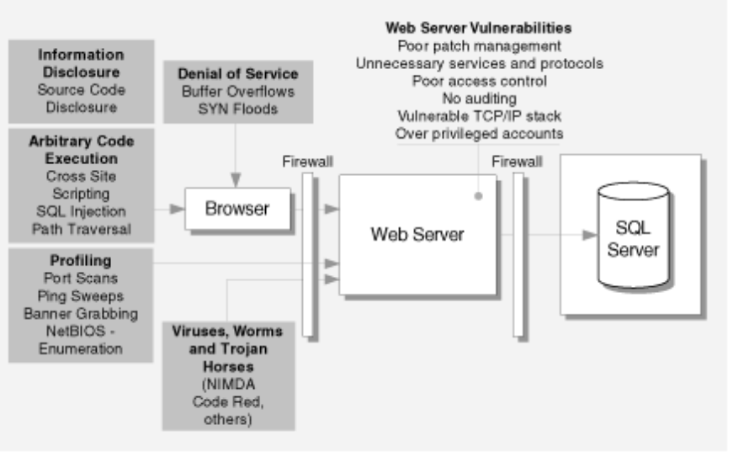
extracted from: https://msdn.microsoft.com/en-us/library/ff648653.aspx

Password Policies

The actual configuration of the network has, minimum length of 8 caracter and password-encryption for the routers. All devices has password.
For the future configuration the user should apply a password policy to match with the network requirements.
This policy applies to the servers and computers connected and also for the network devices.
As good practice, the user should check the features of the devices and see if the devices can support the required configurations for passwords.
The basic setting are:
Password composition policy: It should use at least 3 classes of characters.
Password Length Policy: Should be at least 8 characters and of a good composition, ease for the user to remember and complex enough that no one else can discover.
Password lifetime Policy: That can be in years, months, days, hours, minutes and seconds.
Password Expiry Policy: To check the new password against the other policies.
Password Change Policy: To check the new password against the old one, to make sure the new password will be strong and secure.
User Reautentication Policy: The user will be authenticated against the new password.

SSH

The connection of the Secure Shell should be modeled as appropriated. For now the user 'admin' has privilege 15, it allows the user to do more without the system checks, but if other users has to make use of the connection other levels of security has to be considered. the levels of privileges goes from 0 to 15 and depending of the users needs the privilege has to be analyzed.

Considerations for a more secure network

A access control list could be implemented, and all the packages will be filtered and only the allowed packages will pass by the router.

Firewall Intrusion Detection System It is a intrusion detection at the internal and external area of the network that prevents attacks and threats.
The firewall takes actions on packages that violate the security policy or act as a malicious activity.

Among many other policies that could be implemented at the logical environment where the access and transmission of data occur, the user will have to think about the Physical Security . In this section we need to analyse the risk that the company has. The creditbank will have to check the Risk analysis, Acceptable risk level, Baselines of performance and implemented countermeasures.

The Importance of Physical Security
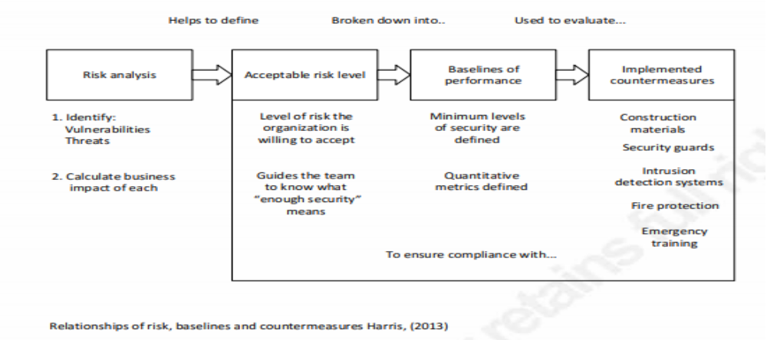
Extracted from: https://www.sans.org/reading-room/whitepapers/physical/physical-security-important-37120

Threats come from every where, with the physical-security we can establish layers and control every side of the network. so when a attack occur, it can be minimized.
It is very important to control the staffs of the company and also any person from out site of the company.
For the staff, the company can give security curses that will teach them how to protect the company against many treats.
And for the people from out-side the company, they have to be controlled, in what parts of the company they can access.
All the physical protection has to be automated and applied in all the levels of security. This protection also keeps the records of accesses and if anything goes wrong, it can be tracked and solved quickly.
The physical-security also have to consider human lives and for that, actions to save the people against natural disasters that treat people and the devices of the network must take place.

The physical-security related to electricity.
All the equipments of the network, and equipments that secure it, requires a good source of electricity. The best practice is to have at least two different sources and use equipments regulate the electricity and as result to keep all the devices working as it should be.
In general, any electromagnetic interference, temperature, humidity, water leakage, fire prevention, should also be checked.

The process of network security is very large, the creditbank company will have to look at all the possible solutions and combine those that will give a good level of security. With those solutions above, if followed, the company will be covered with a good level of security from best practice.

References

SANS (2018). Information Security Policy Templates. Available at: https://www.sans.org/secu
rity-resources/policies/ [Accessed on 6th April 2018]

Microsoft (2018). Securing your web server. Available at: https://msdn.microsoft.com/en-us/li
brary/ff648653.aspx [Accessed on 6th April 2018]

CISCO (2015). Authentication, Authorization, and Accounting Configuration guide, cisco IOS release 15SY. Available at: https://www.cisco.com/c/en/us/td/docs/ios-xml/ios/sec_usr_aaa/co
nfiguration/15-sy/sec-usr-aaa-15-sy-book/sec-aaa-comm-criteria-pwd.html [Accessed on 6th April 2018]

CISCO (2014). chapter: Configuring Cisco IOS firewall Intrusion Detection System. Available at: https://www.cisco.com/c/en/us/td/docs/ios/12_2/security/configuration/guide/fsecur_c/scfid
s.html [Accessed on 6th April 2018]

SANS (2016). Physical Security andwhy it is important. Available at: https://www.sans.org/rea
ding-room/whitepapers/physical/physical-security-important-37120
[Accessed on 6th April 2018]

Appendix
Switch 2

Switch2#show running-config
Building configuration...

Current configuration : 2924 bytes
!
version 12.1
no service timestamps log datetime msec
no service timestamps debug datetime msec
service password-encryption
!
hostname Switch2
!
enable secret 5 $1$mERr$UfH1jjduP2pmRF.APmd4V0
!
ip ssh authentication-retries 2
ip ssh time-out 75
no ip domain-lookup
ip domain-name creditbank.com
!
username admin secret 5 $1$mERr$UfH1jjduP2pmRF.APmd4V0
!
!
spanning-tree mode pvst
!
interface FastEthernet0/1
shutdown
!
interface FastEthernet0/2
shutdown
!
interface FastEthernet0/3
shutdown
!
interface FastEthernet0/4
shutdown
!
interface FastEthernet0/5
shutdown
!
interface FastEthernet0/6
shutdown
!
interface FastEthernet0/7
shutdown
!
interface FastEthernet0/8
shutdown
!
interface FastEthernet0/9
shutdown
!
interface FastEthernet0/10
shutdown
!
interface FastEthernet0/11
shutdown
!
interface FastEthernet0/12
shutdown
!
interface FastEthernet0/13
shutdown
!
interface FastEthernet0/14
shutdown
!
interface FastEthernet0/15
switchport mode access
switchport port-security
switchport port-security maximum 4
switchport port-security mac-address sticky
switchport port-security mac-address sticky 0002.167A.8601
switchport port-security mac-address sticky 0006.2A33.4E7C
switchport port-security mac-address sticky 00D0.D3DB.6603
switchport port-security mac-address sticky 00E0.F748.C813
spanning-tree portfast
!
interface FastEthernet0/16
switchport mode access
switchport port-security
switchport port-security mac-address sticky
switchport port-security mac-address sticky 0030.F2E6.D332
spanning-tree portfast
spanning-tree bpduguard enable
!
interface FastEthernet0/17
switchport mode access
switchport port-security
switchport port-security mac-address sticky
switchport port-security mac-address sticky 0050.0F51.2E27
spanning-tree portfast
spanning-tree bpduguard enable
!
interface FastEthernet0/18
shutdown
!
interface FastEthernet0/19
switchport mode access
switchport port-security
switchport port-security mac-address sticky
switchport port-security mac-address sticky 00D0.FF39.E9A7
spanning-tree portfast
spanning-tree bpduguard enable
!
interface FastEthernet0/20
switchport mode access
switchport port-security
switchport port-security mac-address sticky
switchport port-security mac-address sticky 0002.4A2E.A22C
spanning-tree portfast
spanning-tree bpduguard enable
!
interface FastEthernet0/21
shutdown
!
interface FastEthernet0/22
shutdown
!
interface FastEthernet0/23
shutdown
!
interface FastEthernet0/24
shutdown
!
interface Vlan1
ip address 192.168.1.9 255.255.255.0
!
banner motd ^C
Unauthorized access is strictly prohibited. This device is the property of Creditbank and only authorized users are permitted. ^C
!
!
!
line con 0
password 7 08225E4B0D101115130507
logging synchronous
login
!
line vty 0 4
password 7 08225E4B0D101115130507
login local
transport input ssh
line vty 5 15
login local
transport input ssh
!
!
end
Dublin Router

R1#show running-config
Building configuration...

Current configuration : 1816 bytes
!
version 12.4
no service timestamps log datetime msec
no service timestamps debug datetime msec
service password-encryption
security passwords min-length 8
!
hostname R1
!
!
!
enable secret 5 $1$mERr$UfH1jjduP2pmRF.APmd4V0
!
!
ip dhcp excluded-address 192.168.1.1
ip dhcp excluded-address 192.168.1.5 192.168.1.10
ip dhcp excluded-address 192.168.2.129
ip dhcp excluded-address 192.168.2.254
ip dhcp excluded-address 192.168.2.130
ip dhcp excluded-address 192.168.2.131
!
ip dhcp pool NETWORK1
network 192.168.1.0 255.255.255.0
default-router 192.168.1.1
dns-server 192.168.1.6
ip dhcp pool GUEST
network 192.168.2.128 255.255.255.128
default-router 192.168.2.129
dns-server 8.8.8.8
!
!
!
ip cef
no ipv6 cef
!
!
!
username admin privilege 15 secret 5 $1$mERr$UfH1jjduP2pmRF.APmd4V0
!
!
!
!
!
!
!
!
ip ssh authentication-retries 2
ip ssh time-out 75
no ip domain-lookup
ip domain-name creditbank.com
!
!
spanning-tree mode pvst
!
!
!
!
!
!
interface FastEthernet0/0
ip address 192.168.1.1 255.255.255.0
duplex auto
speed auto
!
interface FastEthernet0/1
ip address 192.168.2.129 255.255.255.128
duplex auto
speed auto
!
interface Serial0/1/0
ip address 200.1.1.1 255.255.255.252
clock rate 64000
!
interface Serial0/1/1
no ip address
clock rate 2000000
shutdown
!
interface Vlan1
no ip address
shutdown
!
ip default-gateway 200.1.1.2
ip classless
ip route 0.0.0.0 0.0.0.0 200.1.1.2
!
ip flow-export version 9
!
!
!
banner motd ^C
Unauthorized access is strictly prohibited. This device is the property of Creditbank and only authorized users are permitted. ^C
!
!
!
!
line con 0
password 7 08225E4B0D101115130507
logging synchronous
login
!
line aux 0
!
line vty 0 4
password 7 08225E4B0D101115130507
login local
transport input ssh
line vty 5 15
login local
transport input ssh
!
!
!
end

ISP router

ISP#show running-config
Building configuration...

Current configuration : 1420 bytes
!
version 12.4
no service timestamps log datetime msec
no service timestamps debug datetime msec
service password-encryption
!
hostname ISP
!
!
!
enable secret 5 $1$mERr$UfH1jjduP2pmRF.APmd4V0
!
!
!
!
!
!
ip cef
no ipv6 cef
!
!
!
username admin privilege 15 secret 5 $1$mERr$UfH1jjduP2pmRF.APmd4V0
!
!
!
!
!
!
!
!
ip ssh authentication-retries 2
ip ssh time-out 75
no ip domain-lookup
ip domain-name creditbank.com
!
!
spanning-tree mode pvst
!
!
!
!
!
!
interface FastEthernet0/0
no ip address
duplex auto
speed auto
!
interface FastEthernet0/0.10
encapsulation dot1Q 10
ip address 172.16.1.1 255.255.255.0
!
interface FastEthernet0/0.20
encapsulation dot1Q 20
ip address 172.16.2.1 255.255.255.0
!
interface FastEthernet0/1
no ip address
duplex auto
speed auto
shutdown
!
interface Serial0/1/0
ip address 200.1.1.2 255.255.255.252
!
interface Serial0/1/1
no ip address
clock rate 2000000
!
interface Vlan1
no ip address
shutdown
!
ip classless
ip route 192.168.0.0 255.255.0.0 200.1.1.1
!
ip flow-export version 9
!
!
!
banner motd ^C
Unauthorized access is strictly prohibited. This device is the property of Creditbank and only authorized users are permitted. ^C
!
!
!
!
line con 0
password 7 08225E4B0D101115130507
logging synchronous
login
!
line aux 0
!
line vty 0 4
password 7 08225E4B0D101115130507
login local
transport input ssh
line vty 5 15
login local
transport input ssh
!
!
!
end

Switch 4

Switch4#show running-config
Building configuration...

Current configuration : 1614 bytes
!
version 12.1
no service timestamps log datetime msec
no service timestamps debug datetime msec
service password-encryption
!
hostname Switch4
!
enable secret 5 $1$mERr$UfH1jjduP2pmRF.APmd4V0
!
ip ssh authentication-retries 2
ip ssh time-out 75
no ip domain-lookup
ip domain-name creditbank.com
!
username admin secret 5 $1$mERr$UfH1jjduP2pmRF.APmd4V0
!
!
spanning-tree mode pvst
!
interface FastEthernet0/1
!
interface FastEthernet0/2
!
interface FastEthernet0/3
!
interface FastEthernet0/4
!
interface FastEthernet0/5
!
interface FastEthernet0/6
!
interface FastEthernet0/7
!
interface FastEthernet0/8
!
interface FastEthernet0/9
!
interface FastEthernet0/10
!
interface FastEthernet0/11
!
interface FastEthernet0/12
!
interface FastEthernet0/13
!
interface FastEthernet0/14
!
interface FastEthernet0/15
!
interface FastEthernet0/16
!
interface FastEthernet0/17
switchport access vlan 20
switchport mode access
!
interface FastEthernet0/18
!
interface FastEthernet0/19
!
interface FastEthernet0/20
switchport mode trunk
!
interface FastEthernet0/21
!
interface FastEthernet0/22
switchport access vlan 10
switchport mode access
!
interface FastEthernet0/23
!
interface FastEthernet0/24
!
interface Vlan1
ip address 172.16.0.1 255.255.255.0
!
banner motd ^C
Unauthorized access is strictly prohibited. This device is the property of Creditbank and only authorized users are permitted. ^C
!
!
!
line con 0
password 7 08225E4B0D101115130507
logging synchronous
login
!
line vty 0 4
password 7 08225E4B0D101115130507
login local
transport input ssh
line vty 5 15
login local
transport input ssh
!
!
end

